|  |  |  |  |  |  |
| --- | --- | --- | --- | --- | --- |
| **2025年第八届“放飞梦想 律动津城”天津律师体育节 台球比赛报名及运动服尺码登记表** | | | | | |
| 所属区域：（加盖公章） | | | | | |
| 领队姓名： 领队电话：  **注：请各区律工委结合本区实际情况，自主补充参赛律师报名情况** | | | | | |
| **序号** | **姓名** | **单位名称** | **联系电话** | **尺码 （S-4XL)** | **备注** |
| 1 |  |  |  |  |  |
| 2 |  |  |  |  |  |
| 3 |  |  |  |  |  |
| 4 |  |  |  |  |  |
| 5 |  |  |  |  |  |
| 6 |  |  |  |  |  |
| 7 |  |  |  |  |  |
| 8 |  |  |  |  |  |
| 9 |  |  |  |  |  |
| 10 |  |  |  |  |  |
| 11 |  |  |  |  |  |
| 12 |  |  |  |  |  |
| 13 |  |  |  |  |  |
| 14 |  |  |  |  |  |
| **以下为台球POLO衫尺码参照信息图，仅供参考** | | | | | |

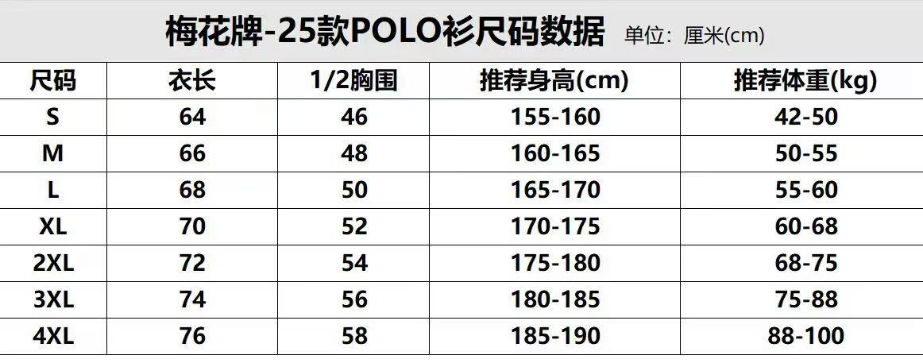

|  |  |  |  |  |  |  |  |
| --- | --- | --- | --- | --- | --- | --- | --- |
| **2025年第八届“放飞梦想 律动津城”天津律师体育节 乒乓球比赛报名及运动服尺码登记表** | | | | | | | |
| 所属区域：（加盖公章） | | | | | | | |
| 领队姓名： 领队电话：   **注：请各区律工委结合本区实际情况，自主补充参赛律师相关项目内容** | | | | | | | |
| **序号** | **姓名** | **项目** | **性别** | **单位名称** | **联系电话** | **尺码 （S-5XL)** | **备注** |
| 1 |  | 男单1 | 男 |  |  |  |  |
| 2 |  | 男单2 | 男 |  |  |  |  |
| 3 |  | 女单1 | 女 |  |  |  |  |
| 4 |  | 女单2 | 女 |  |  |  |  |
| 5 |  | 男双1 | 男 |  |  |  |  |
|  |  |  |  |  |
| 6 |  | 男双2 | 男 |  |  |  |  |
|  |  |  |  |  |
| 7 |  | 女双1 | 女 |  |  |  |  |
|  |  |  |  |  |
| 8 |  | 女双2 | 女 |  |  |  |  |
|  |  |  |  |  |
| 9 |  | 混双1 | 男 |  |  |  |  |
|  | 女 |  |  |  |  |
| 10 |  | 混双2 | 男 |  |  |  |  |
|  | 女 |  |  |  |  |
| **以下为乒乓球运动服尺码参照信息图，仅供参考** | | | | | | | |
| 515f4467b36c8a3af6a7a3c70963f44 | | | | | | | |

|  |  |  |  |  |  |  |  |  |
| --- | --- | --- | --- | --- | --- | --- | --- | --- |
| **2025年第八届“放飞梦想 律动津城”天津律师体育节 羽毛球比赛报名及运动服尺码登记表** | | | | | | | | |
| 所属区域：（加盖公章） | | | | | | | | |
| 领队姓名： 领队电话：  **注：请各区律工委结合本区实际情况，自主补充参赛律师相关项目内容** | | | | | | | | |
| **序号** | **姓名** | **项目** | **性别** | **年龄** | **单位名称** | **联系电话** | **尺码 （S-5XL)** | **备注** |
| 1 |  | 男单1 | 男 |  |  |  |  |  |
| 2 |  | 男单2 | 男 |  |  |  |  |  |
| 3 |  | 女单1 | 女 |  |  |  |  |  |
| 4 |  | 女单2 | 女 |  |  |  |  |  |
| 5 |  | 男双1 | 男 |  |  |  |  |  |
|  |  |  |  |  |  |
| 6 |  | 男双2 | 男 |  |  |  |  |  |
|  |  |  |  |  |  |
| 7 |  | 女双1 | 女 |  |  |  |  |  |
|  |  |  |  |  |  |
| 8 |  | 女双2 | 女 |  |  |  |  |  |
|  |  |  |  |  |  |
| 9 |  | 混双1 | 男 |  |  |  |  |  |
|  | 女 |  |  |  |  |  |
| 10 |  | 混双2 | 男 |  |  |  |  |  |
|  | 女 |  |  |  |  |  |
| 11 |  | 混合团体 |  |  |  |  |  |  |
|  |  |  |  |  |  |
|  |  |  |  |  |  |
|  |  |  |  |  |  |
|  |  |  |  |  |  |
|  |  |  |  |  |  |
| 12 |  | 百岁男双1 | 男 |  |  |  |  |  |
|  |  |  |  |  |  |
| 13 |  | 百岁男双2 | 男 |  |  |  |  |  |
|  |  |  |  |  |  |
| 14 |  | 百岁女双1 | 女 |  |  |  |  |  |
|  |  |  |  |  |  |
| 15 |  | 百岁女双2 | 女 |  |  |  |  |  |
|  |  |  |  |  |  |
| 16 |  | 百岁混双1 | 男 |  |  |  |  |  |
|  | 女 |  |  |  |  |  |
| 17 |  | 百岁混双2 | 男 |  |  |  |  |  |
|  | 女 |  |  |  |  |  |
| 注：百岁组，每名队员年龄不能低于45周岁，相加年龄不能低于100周岁 | | | | | | | | |
| **以下为羽毛球运动服尺码参照信息图，仅供参考** | | | | | | | | |

